**SMART PRESCRIPTION APPLICATION**

Project Proposal

By

Mr. Natthakan Kaeokanpai 552115020

Mr. Phithiwat   Sitthitun     552115051

Department of Software Engineering

College of Arts, Media and Technology

Chiang Mai University

Project Advisor

_____________________________

Dr.Prompong Sugunnasil

**Document story**

|  |  |  |  |  |  |  |
| --- | --- | --- | --- | --- | --- | --- |
| **Document name** | **Detail** | **Status** | **Date** | **Viewable** | **Editable** | **Responsible** |
| **Document** | | | | | | |
| Smart Prescription Application  Proposal V.0.1 Docx | **- Add**  Chapter One  **- Add**  Chapter Two  **- Add**  Chapter Three  **- Add**  Chapter Four  **- Add**  Chapter Five | Drafted | March 10th 2016 | NAT, PHI, PROM | NAT, PHI | NAT, PHI |
| Smart Prescription Application  Proposal  V.1.0 Docx | **- Update**  Chapter One  **- Update**  Chapter Two  **- Update**  Chapter Three  **- Update**  Chapter Four  **- Update**  Chapter Five | Released | May  20th 2016 | NAT, PHI, PROM | NAT, PHI | NAT, PHI |

*Acronym*

NAT = Natthakan Kaeokanpai

PHI = Phithiwat Sitthitun

PROM = Prompong Sugunnasil

**Abstract**

Nowadays, mobile applications have become very popular and required by many organizations. Since the mobile application is portable, it could provide the service on site and in real time. Therefore, it has become ubiquitous. One of the area that mobile application could be used is the drug prescription. Normally, the prescription is given by the doctor to the patient. Then, the patient will take the prescription to the pharmacist and receive the drug.

However, there are some limitations to the traditional system. The first thing is that the doctor’s handwriting often is not readable. As a consequence, it could lead to fatal situation. In USA, patients died more than 7,000 pupils each year and increased every year [1]. By using the paper based prescription, there could be an imposter getting the controlled drugs. Moreover, the drug that has level of allergy needs to be reported to the Food and Drug Administrator (FDA) as quickly as possible. To encounter the mentioned problems, the service to manipulate the information is required.

According to that, we develop an application that consists of a web application and a mobile application. Smart prescription application requires a web application for creating a patient‘s profile and allergy report by a doctor and the Smart prescription application require a mobile application to generate and scan the QR code on a mobile phone by a pharmacist.

**Table of Contents**

Chapter One | Introduction and background 5

Chapter Two | Literature Review 6

2.1 Business Review 6

2.2 Technology Review 8

2.3 Development Tool Review 12

Chapter Three | Quality Standard 15

3.1 ISO 29110 for Very Small Entity (VSE) [11] 15

Chapter Four | Project Plan 16

4.1 Motivation 16

4.2 Aims and objectives 16

4.3 Deliverables and limits 17

4.3.1 System Architecture 17

4.3.2 Deliverables 18

4.3.3 Limits 18

4.4 Future work 18

4.5 Software Process 19

4.6 Schedule & Milestone 20

4.6.1 Features 20

4.6.2 Relation between Features and Users 22

4.6.3 Milestone 22

Chapter Five | References 23

# Chapter One | Introduction and background

According to the survey, first one is doctors' handwriting kills more than 7,000 people. It's a terrible statistic, and according to a report from the National Academies of Science's Institute of Medicine (IOM), show medication fails also making people injured more than 1.5 million. Many such errors result from unclear acronym and dosage indications. Second one is, the problem about using the paper based prescription there are prescription forgeries used to make methamphetamine. Third one is problem about level of allergy about most drug allergy that found in each area needs to be reported Food and Drug Administration, Ministry of Public Health organization or (FDA)

Technology use for prescriptions to reduce to reduce the error rate from unclear handwriting of doctor by change prescription that written with pen to electronic prescriptions by using Quick Response Code (QR Code) stored a list of medications, detail of medicine, dosage of medicine and medicine allergy history. The QR code system has a high security because supported “error correction algorithm” [2] capability to restore data if the code is dirty or damaged.

Smart prescription application consists of a web application and an android application and separates the users for four sides that are doctor, patient, FDA and pharmacist. The main of feature is a prescription system that working with the QR code system. By getting the prescription instantly in a user’s Smartphone. Inside of QR code contains a list of medications, size of medicine and information of patient. . Smart prescription application requires a mobile application for scan QR code by the pharmacist. Pharmacist can get the prescription with the name of patient and detail of drug that doctor give to a patient on a mobile application.

Another feature of the Smart prescription application is Allergy system and Summary allergy report system that can collect and report the medicine allergy history by doctor to the FDA for observing unusually dispensation in Thailand. All these things are the beginning of a smart prescription application.

# Chapter Two | Literature Review

## 2.1 Business Review

**2.1.1 Prescription application**

**2.1.1.1 mDoctor android application[3]**

mDoctor is an android application that works with Telemedicine Working Group Bangladesh where one can get medical advice and prescription from various specialist. The doctor can diagnose your disease and give you medical advice as well as prescribe medications by mDoctor application. mDoctor application allows phone call or Skype video conferencing with doctor from home. mDoctor application uses mobile and internet technologies to put patients in touch with specialist doctors from anywhere.

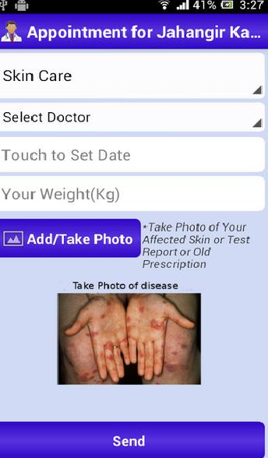 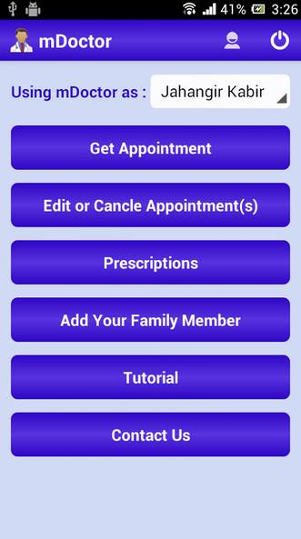

*Figure 1: User interface of “mDoctor”*

2.1.1.1.1 Pros

* User can schedule an appointment and choose user preferred doctor from the list.
* User can get the prescription instantly in user‘s mobile.
* System helps you to talk with the consultants directly.
* System provides access to a wider range of specialist advice and services.
* System deliver faster and more efficient health care by using technology

2.1.1.1.2 Cons

* Doctor do not get sufficient detail about the patient.
* The application can only work in Bangladesh

**2.1.1.2 Prescription Monitor application[4]**

Prescription Monitor application is an android application design to help the management of all your prescriptions such as refilling time. After entering all prescriptions and linking them to the appropriate family member, physician, and pharmacy, the application automatically keeps track of how many pills are left for each prescription. Based on how many pill taken daily, the application automatically calculates how many pills are left for each prescription and display it graphically on a screen.

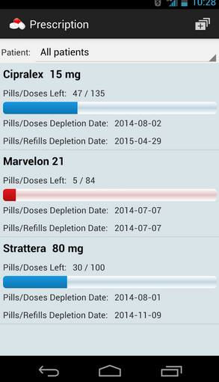 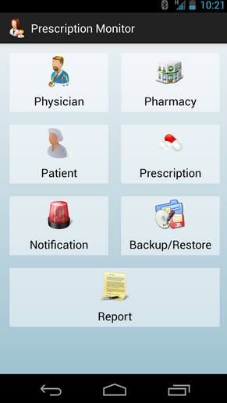

*Figure 2: User interface of “Prescription Monitor”*

2.1.1.1.1 Pros

* User can be tracked history of medicine
* User can Backup / Restore drug information.
* System helps user to find direction to pharmacy
* System can alert to user when a prescription has a certain amount of pills left and/or refill left

2.1.1.1.2 Cons

* System cannot directly confirmed prescription from doctor
* System missing the security for sensitive data
* System missing the identity verification to access to application

## 2.2 Technology Review

**2.2.1 Android Operating System [6]**



*Figure 2:* Android operating system

**Technology Description**

Android is an operating system based on Linux kernel. It is free and open source. Android is mainly used in mobile devices, such as smartphones and tablets. Android released with a series of the core application package. The application package includes client, SMS short message application, calendar, maps, browser and etc. All applications are written in JAVA language. The developers can also access to the API frameworks that used by the core application.

**Alternative technology**

- iOS

- Windows phone

- Black Berry Rim

- Palm OS

**The selection of technology**

- Android can run many application.

- Android development technology is easy to learn.

- Android is an open source application.

**2.2.3 MySQL[7]**



*Figure 3: MySQL*

**Technology Description**

MySQL is a popular choice of database for use in web applications, and is a central component of the widely used LAMP open source web application software stack (and other 'AMP' stacks). LAMP is an acronym for "Linux, Apache, MySQL, Perl/PHP/Python." Free-software-open source projects that require a full-featured database management system often use MySQL.

**Alternative technology**

- SQLite  
 - Oracle Database

**-** [PostgreSQL](https://www.g2crowd.com/products/postgresql/reviews)

**The selection of this technology**

- MySQL server has been thoroughly tested to prevent memory leaks.  
- MySQL runs on many operating systems.

**2.2.5 PHP version 5.6.15 [8]**



*Figure 4: PHP version 5.6.15*

**Technology Description**

PHP is a server-side scripting language created in 1995 and designed for web development but also used as a general-purpose programming language. As of January 2013, PHP was installed on more than 240 million websites (39% of those sampled) and 2.1 million web servers. Originally created by Rasmus Lerdorf in 1994,the reference implementation of PHP (powered by the Zend Engine) is now produced by The PHP Group. While PHP originally stood for Personal Home Page, it now stands for PHP: Hypertext Preprocessor, which is a recursive backronym.

**Alternative technology**

- ASP.NET  
 - JSP

**The selection of this technology**

- PHP can build dynamic web application and web service.  
 - PHP is fast, flexible and pragmatic.

**2.2.6 Yii framework [9]**

*****Figure 5 : Yii*

**Tool description**

Yii is a high-performance PHP framework best for developing Web 2.0 applications. Yii comes with rich features: MVC, DAO/ActiveRecord, I18N/L10N, caching, authentication and role-based access control, scaffolding, testing, etc. It can reduce your development time significantly.

**Alternative tool**

- .NET framework  
 - Spring framework  
 - Hibernate framework

**The selection of this tool**

- Yii only loads the features that you need.  
- Yii develop clean and reusable code.

## 2.3 Development Tool Review

**2.3.1 Android Studio [10]**

**

*Figure 6: Android Studio*

**Technology Description**

Android Studio is the official IDE for Android application development, based on IntelliJ IDEA. On top of the capabilities you expect from IntelliJ.

**Alternative technology**

- IntelliJ IDEA  
 - Eclipse

**-** Xcode

**The selection of this technology**

- Android Studio is flexible to build the system.  
 - Android Studio has a code templates to help you build common app features.  
 - Android Studio can improve interface design perspective.

**2.3.2 PHP Storm version 10 [11]**

**

*Figure 7: PHP Storm version 10.0.3*

**Technology description**

​PhpStorm’s smart code editor provides excellent support for PHP (including the latest language versions and frameworks), HTML, JavaScript, CSS, Sass, Less, CoffeeScript, and many other languages. Enjoy coding with intelligent context-aware code completion, error detection, and on-the-fly code inspections & fixes.

**Alternative technology**

- Eclipse

- Visual Studio  
 - IntelliJ IDEA  
 - Dreamweaver

**The selection of this tool** - PhpStorm supports all PHP language features for modern and legacy projects.

- PhpStorm can quickly verify the code and fix it.- PhpStorm can specify methods to be ordered after fields or keep dependent methods together.

**2.3.3 XAMPP [12]**

**

*Figure 8: XAMPP*

**Technology description**

​XAMPP is a completely free, easy to install Apache distribution containing MySQL, PHP, and Perl. The XAMPP open source package has been set up to be incredibly easy to install and to use.

**Alternative technology**

- Appserv

- WAMPP

**The selection of this tool** - XAMPP is portable so you can carry it around on a thumb drive.

- XAMPP can start and stop the whole webserver and database stack with one command.- XAMPP supports for creating and manipulating databases.

# Chapter Three | Quality Standard

## 3.1 ISO 29110 for Very Small Entity (VSE) [11]

ISO 29110 is a guide applies to a very small entity, enterprise, organization, department or project up to 25 people dedicated to software development. The guide provides project management and software implementation process which integrate practice based on the selection of ISO/IEC 12207 systems and software engineering-software life cycle process and ISO/IEC 15289 software engineering-software life cycle process guideline for the content of software life cycle process information product (documentation) standards elements

**3.1.1 Project management process**

The purpose of the software management process is to establish and carry out in a systematic way the task of the software implementation project which allows complying with the project’s objectives in the expected quality. Time and cost

**Selected process**

3.1.1.1 Project planning process

3.1.1.2 Project plan execution process

3.1.1.3 Project assessment and control process

3.1.1.4 Project closer process

**3.1.2 Software implementation process**

The purpose of the software implementation process is the systematic performance of the analysis, design, construction, integration and test actives for new or modified software products according to the specified requirements.

**Selected process**

3.1.2.1 Software implementation process

3.1.2.2 Software requirement analysis process

3.1.2.3 Software architectural design process

3.1.2.4 Software construction process

3.1.2.5 Software integration process and test process

3.1.2.6 Software delivery process

# Chapter Four | Project Plan

## 4.1 Motivation

We have two big motivations to develop a medication management system. The first one is for solve dislocation of prescriptions from dislocation of prescriptions that can help patient to be safe in the treatment.

Second is helping Food and Drug Administration, Ministry of Public Health organization or (FDA) get the report of unusually dispensation from all history of user's prescription and FDA can get report of drug allergy that found in history of user's prescription for protect dispensing dangerous drug to patient.

## 4.2 Aims and objectives

**4.2.1 Aims**

The aim of this application is to develop a web application and an android application that can help doctor and pharmacists to mutual understanding about the correct prescription in form QR code. It is an optimize prescriptions to reduces or eliminates the expense. And the application can also help to keeps a record of all prescription' history to FDA for check unusually drug allergy.

* Mutual understanding between pharmacists and doctor about list of medicine on prescription.
* Reduce paper use of prescription.
* Safe from counterfeiting documents.
* Food and Drug Administration, Ministry of Public Health can observe all dispensations for check unusually drug allergy.
* More convenience for patient, pharmacists, FDA and doctors to use prescription.

**4.2.2 Objectives**

* To develop the web application that can create prescription of patient, use for doctor.
* To develop the mobile application run on Android devices that can create QR code from prescription, use for patient.
* To develop the mobile application run on Android devices that can scan QR code, use for pharmacists
* To develop the web application that can create allergy report, use for doctor.
* To develop the web application that can view allergy report, use for Food and Drug Administration Ministry of Public Health (FDA).

## 4.3 Deliverables and limits

### 4.3.1 System Architecture

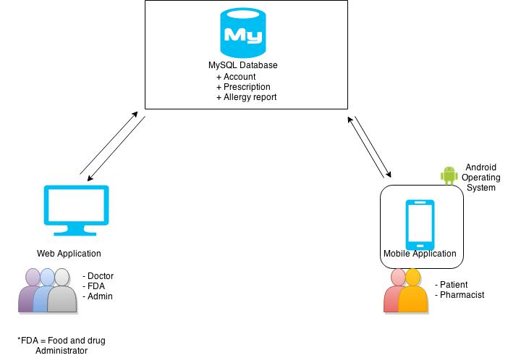

*Figure 9: System Architecture*

The architecture of “Smart Prescription Application”, show in the figure 10, consists of two parts. The first part is the web application. In this system, there are three types of user doctor, FDA and admin. The users can use web application via a web browser by access to the web application by login. Doctors can create the patient’s profiles and allergy report to MySQL database. The FDAs can view the allergy report on the web application. An admin can create and manage account of doctor and FDA to MySQL database.

The second part is the mobile application Smart Prescription Application stand for android operating system. There have two types of users; patients and pharmacists. Patients can view the QR code on the mobile application. Pharmacist can verify QR code and get the information of patient’s profile by scan QR code function on the mobile application.

### 4.3.2 Deliverables

- Proposal

- Project plan

- Software requirement specification

- Software design document

- Testing document

- Traceability record

- Software quality assurance document

- Certification client and server system

- Video clips for demo program

- Poster A1 for presentation

### 4.3.3 Limits

- The system supports smartphones which run on Android OS 2.2 or newer.

- The system supports the English language only.

- The system require internet for access

- The system can encode to English language, numeric and binary(8 bits) only.

- The applications require the same application to encode from QR code.

## 4.4 Future work

* This application can be improve to support more facility such animal hospital.
* This application can categorize in each types of medication.
* This application can improve security of access to account on the application.
* This application can support other platforms such as IOS.
* This application can support another language on display screen.

## 4.5 Software Process

**Waterfall software development [12]**

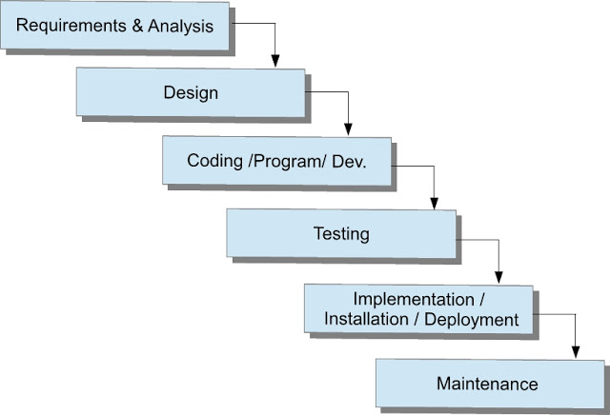

*Figure 10: Waterfall development model*

The waterfall model is a sequential design process, often used in software development processes, in which progress is seen as flowing steadily downwards (like a waterfall) through the phases of Requirement & Analysis, Design, Code, Testing, Implementation and Maintenance. The waterfall model proceeds from one phase to the next in a sequential manner.

When requirements are completed, one proceeds to design. The software in question is designed and a blueprint is drawn for implementers (coders) to follow—this design should be a plan for implementing the requirements given.

When the design is complete, an implementation of that design is made by coders in appropriate coding language which is best suited to design.

Once code is finalized then through testing of code is begin. All testing activities are done in this phase.

After testing, the application is being ready to deploy in actual server environment. This phase is implementation phase of actual product.

Once Application deployed successfully, we can easily modified the application in maintenance phase. The entire customer enhancement, modification has to be done in this phase.

## 4.6 Schedule & Milestone

### 4.6.1 Features

**Process 1:** Proposal and Project plan

**Process 2**

**Feature#1:** Prescription system

**Description:** This feature supports the doctor to manage patient’s profile. The doctor can create, delete, search, update and view patient’s profile on the web application.

**User:** Doctor

**Detail:** 1: Doctors can create patient’s profiles on the web application.

2: Doctors can update patient’s profiles on the web application.

3: Doctors can delete patient’s profiles on the web application.

4: Doctors can search patient’s profiles on the web application.

5: Doctors can view patient’s profiles on the web application.

6: Doctors can view a list of patient’s profiles on the web application.

**Feature#2:** Account management system **Description:** This feature supports the administrator to manage user’s profile.

The administrators can create, delete, search, update, and view user’s profile on the web application.

**User:** Administrator

**Detail:** 1: Administrations can create user’s profiles on the web application.

2: Administrations can update user’s profiles on the web application.

3: Administrations can delete user’s profiles on the web application.

4: Administrations can search user’s profiles on the web application.

5: Administrations can view user’s profiles on the web application.

6: Administrations can view a list of users on the web application.

**Feature#3:** Authentication system **Description:** This feature supports accessing to the system and exiting from the system. Doctor, FDA, patients, and administrator can login to the system and log-out from the system.  
**User:** Doctor, FDA, patients, and administrator  
**Detail:** 1: Doctors, Administrations, and FDAs can login to the web application.

2: Doctors, Administrations, and FDAs can logout from the web application.

3: Patients can login to the mobile application.

4: Patients can logout from the mobile application.

**Feature#4:** Verification system **Description:** This feature supports the patients to view QR code on the mobile application and pharmacist can verify the QR code by use scan QR code function and also can add the time of dispensation to patient’s prescription on the mobile application.

**User:** Patient and pharmacist

**Detail:** 1: Patients can view the QR code on the mobile application.

2: Pharmacists can scan the QR code on the mobile application.

3: Pharmacists can add the time of dispensation to patient’s profile on the mobile application.

**Feature#5:** Allergy report system **Description:** This feature supports doctor can report a drug allergy to FDA on web application. The doctors can create, delete, search, update, and view drug allergy on the web application.

**User:** Doctor

**Detail:**  
 1: Doctors can create allergy reports on the web application.

2: Doctors can update allergy reports on the web application.

3: Doctors can delete allergy reports on the web application.

4: Doctors can search allergy reports on the web application.

5: Doctors can view allergy drug reports on the web application.

6: Doctors can view a list of allergy drug reports on the web application.

**Feature#6:** Summary allergy report system **Description:** This feature supports the FDA can view the all list of allergy report on web application.  
**User:** FDA  
**Detail:**

1: FDAs can view allergy reports on the web application.

2: FDAs can view a list of allergy reports on the web application.

.

### 4.6.2 Relation between Features and Users

|  |  |  |  |  |  |  |  |  |  |  |
| --- | --- | --- | --- | --- | --- | --- | --- | --- | --- | --- |
| Feature | Doctor | | Patient | | Pharmacist | | FDA | | Admin | |
| Web app | Mobile app | Web app | Mobile app | Web app | Mobile app | Web app | Mobile app | Web app | Mobile app |
| Feature#1 | x |  |  |  |  |  |  |  |  |  |
| Feature#2 |  |  |  |  |  |  |  |  | x |  |
| Feature#3 | x |  |  | x |  |  |  |  | x |  |
| Feature#4 |  |  |  | x |  | x |  |  |  |  |
| Feature#5 | x |  |  |  |  |  |  |  |  |  |
| Feature#6 |  |  |  |  |  |  | x |  |  |  |

### 4.6.3 Milestone

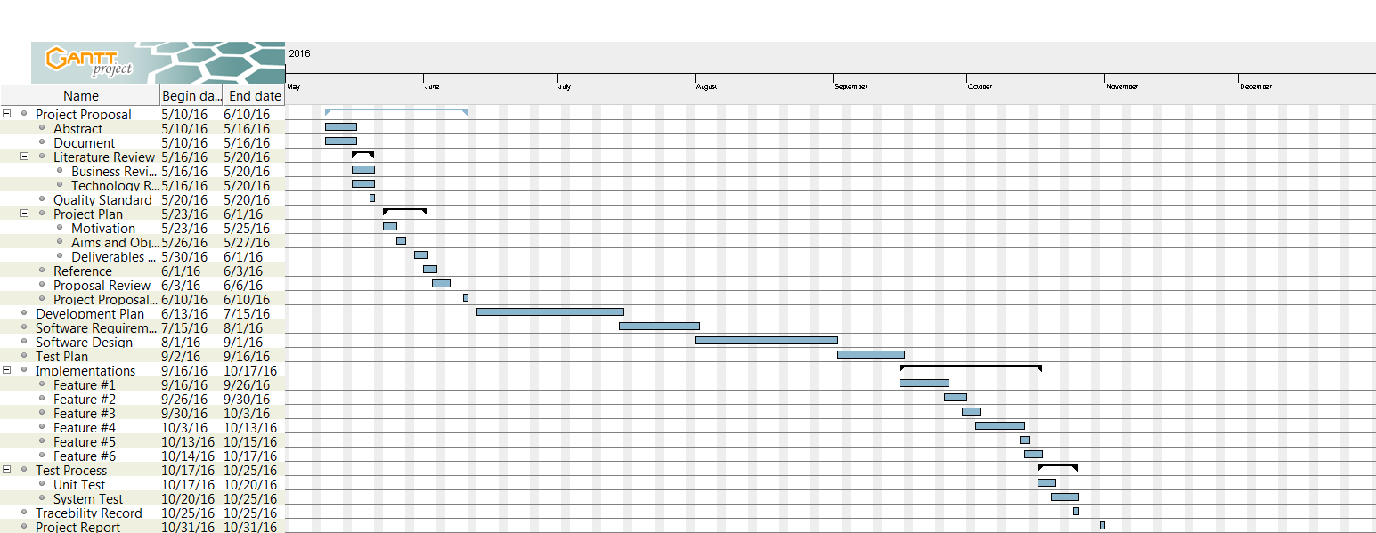

*Figure 11: Project Milestone*

# Chapter Five | References

[1] [Death by prescription](https://www.google.co.th/url?sa=t&rct=j&q=&esrc=s&source=web&cd=4&ved=0CDAQFjAD&url=http%3A%2F%2Fwww.emirates247.com%2Fnews%2Femirates%2Fdeath-by-prescription-doctors-handwriting-causes-7-000-deaths-a-year-2012-11-04-1.481418&ei=olldVbukAsaiugTO94LwCw&usg=AFQjCNEVZgfqnEj8kinU5_2FldXL9ikeIw&sig2=Nr-I_L3phIRis0-XmKwfKw&bvm=bv.93756505,d.c2E&cad=rja)

- http://www.emirates247.com/news/emirates/death-by-prescription-doctors-handwriting-causes-7-000-deaths-a-year-2012-11-04-1.481418

[2] Error correction feature

- http://www.qrcode.com/en/about/error_correction.html

[3] mDoctor application

- https://play.google.com/store/apps/details?id=com.jahanbabu.mdoctor&hl=en

[4] Prescription Monitor

-https://play.google.com/store/apps/details?id=ca.charboapps. prescriptionmanagerfull&hl=en

[6] Android Operation System -- Android, Inc

- http://www.android.com/

- http://en.wikipedia.org/wiki/Android_(operating_system)

[7] MySQL

- http://en.wikipedia.org/wiki/MySQL

- http://www.mysql.com/

[8] PHP

- http://en.wikipedia.org/wiki/PHP

- <http://php.net>

[9] Yii framework

- http://www.yiiframework.com/

[10] Android Studio -- Android, Inc

- https://developer.android.com/sdk/index.html

[11] ISO29110

- http://www.iso.org/iso/home.htm

[12] Waterfall software development

- http://vikasthange.blogspot.com/2012_08_01_archive.html